ENGR 301 Tutorial 5 CFDs and equivalencies using single amount and uniform series

1. Develop a cash flow diagram based on the following information:

A university graduate has a monthly income of $2200, received at the end of each month. Out of this the student pays for rent, food, entertainment, telephone charges, and a credit card for all other purchases. Rent is $700 per month (including utilities), due at the end of each month. Weekly food and entertainment expenses total roughly $120, a typical telephone bill is $40 (due at the end of the first week in the month), and credit card purchases average $300. Credit card purchases are due at the end of the second week of the month.

1. The following cash flows are equivalent in value if the interest rate is i. Which one is more valuable if the interest rate is 2i?

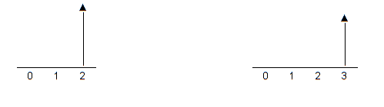

1. The US recently purchased $1 billion in 30-year zero-coupon bonds from a struggling foreign nation. The bonds yield 4.5% per year interest. The zero-coupon bonds pay no interest during their 30-year life. Instead, at the end of 30 years, the US government is to receive back its $1 billion together with an interest of 4.5% per year. A US senator objects to the purchase, claiming that the correct interest rate for bonds like this is 5.25%. The result, he said, was a multimillion dollar gift to the foreign country without the approval of Congress. Assuming that the senator’s math is correct, how much will the foreign country have saved in interest when it repays the bonds at 4.5% instead of 5.25% at the end of 30 years?
2. What single sum of money at t=4 is equivalent to the cash flow profile shown below? Use a 6% interest rate in your analysis.

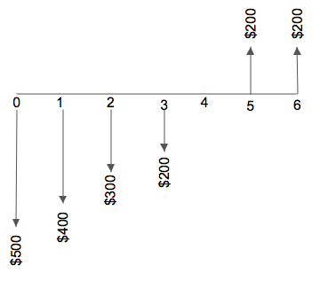

1. Assume payments of $2000, $5000 and $3000 are received at t=3,4, and 5, respectively. What five equal payments occurring at t=1,2,3,4 and 5, respectively, are equivalent if i=10% compounded per period.

1. What single deposit of size $X into a fund paying 10% compounded annually is required at t=0 in order to make withdrawals of $500 each at t=4, 5, 6 and 7, and a single withdrawal of $1000 at t=20?